**Practical No.1**

* Write a program for tokenization of given input.

1)Sentense tokenization.

**Input:**

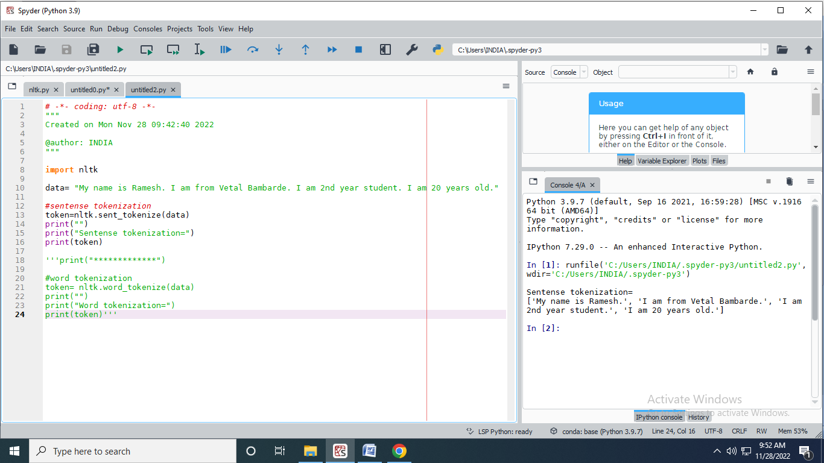

**Output:**



2)Word tokenization:

**Input:**

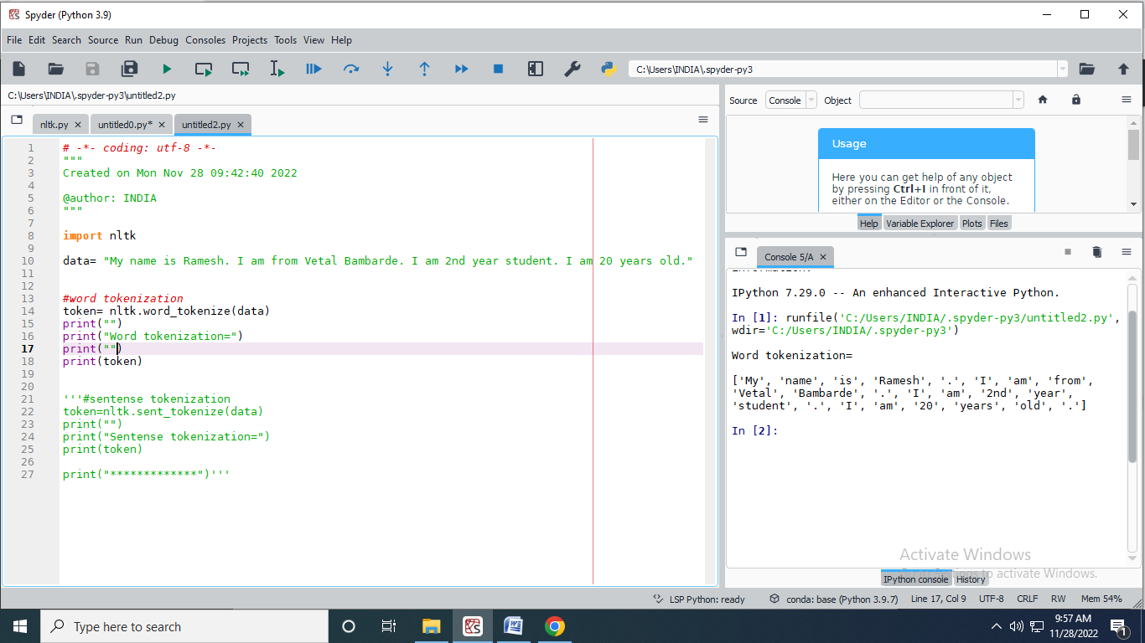

**Output:**

